# Validace ( prekopirovano z WordPadu z Vesmiru + neco navic)

‎17 ‎August, ‎2017

* **VALIDACE :**
* [**https://github.com/JeremySkinner/FluentValidation/wiki**](https://github.com/JeremySkinner/FluentValidation/wiki)

using FluentValidation;

public class CustomerValidator : AbstractValidator<Customer> **dedime od Abstraktni tridy**

{

public CustomerValidator() **// Vytvorime nejake pravidla validace**

{

RuleFor(customer => customer.Surname).NotEmpty();

RuleFor(customer => customer.Forename).NotEmpty().WithMessage("Please specify a first name");

RuleFor(customer => customer.Discount).NotEqual(0).When(customer => customer.HasDiscount);

RuleFor(customer => customer.Address).Length(20, 250);

RuleFor(customer => customer.Postcode).Must(BeAValidPostcode).WithMessage("Please specify a valid postcode");

}

private bool BeAValidPostcode(string postcode)

{

// custom postcode validating logic goes here

}

}

Customer customer = new Customer(); **// Nova instance customera**

CustomerValidator validator = new CustomerValidator(); **// Nova instance validatoru**

ValidationResult **results** = validator.Validate(customer); **// Pomoci metody rodice validujeme customera**

bool validationSucceeded = **results**.IsValid; **// Boolean true nebo false podle toho jestli validace prosla**

IList<ValidationFailure> failures = **results**.Errors; **// Seznam chyb ke kterym doslo pri validaci, podle nasich pravidel.**

============================================================================================================================================================================

* Trida ktera chce pouzivat validaci (tady GalaxyDialogViewModel ) musi implementovat rozhrani IDataErrorInfo.
* Toto rozhrani ma dve property :

1. string this[string columnName] { get; } to je pole stringovych objektu IDataErrorInfo
2. string Error { get; }

* Implementaci rozhrani budou tyto dve property i v nasi tride .
* Do tridy si pridame vnitrni tridu CustomValidator : AbstractValidator<GalaxyDialogViewModel>
* Kde v konstruktoru budou pravidla ktere chceme zkoumat.
* A budeme tu mit propertu: protected IValidator Validator { get; } = new CustomValidator(); na ktere budeme validovat.
* Pozdeji jsem to predelal tak , aby se dedilo od tridy ErrorBase . Ta dedi od ViewModelBase kvuli rozhrani INotify , takze tridy ktere budou dedit od ErrorBase uz budou mit vyreseno INotify, IDataErrorInfo a budou uz mit validaci v predkovi.
* Na samotne tride ktera bude chtit neco validovat , pak zustene jen vytvorit vnitrni tridu CustomValidator a v jejim konstruktoru definovat co se bude testovat. :

RuleFor(d => d.Jmeno).NotEmpty().WithMessage("Jmeno musi byt vyplneno.");

* V konstruktoru jen zavolam metodu na predkovi Validate a jako parametr ji predhodim instanci sveho customValidatoru :

Validate(new CustomValidator());

* V xaml musime na komponente ktera se bude validovat zadefinovat:

1. UpdateSourceTrigger=PropertyChanged => ViewModel potrebuje vedet o tom ze se komponenta zmenila , jinak by nemohl vedet o chybe.
2. ValidatesOnDataErrors=True =>
3. NotifyOnValidationError=True =>
4. ToolTip="{Binding Path=Error}" => Vypis napovedy pro uzivatele definovany v customValidatoru

* Take je nutne notifikovat view o zmenach ve viewModelu . K tomu nam slouzi INotify s tim ze neinformujeme o zmene vlastnosti ale o zmene booleanu **IsValid** a stringu **Error**.:

OnPropertyChanged(nameof(Error));

OnPropertyChanged(nameof(IsValid));

* Povoleni tlacitek je nastaveno v RelayCommandu na druhem parametru, da se to udelat i v xaml a to nasledovne: (nefunguje bzzz)

CommandParameter="{Binding Path=IsValid}"

**VE SKENOVADLE JE POUZITY NA EDITPUBLICATIONVIEWMODELU , DEDI OD ERRORBASE**

**Ukoly:**

* ~~Ramecek v okne kde se budou vypisovat chyby~~
* Dovalidovat okna
* ~~Zablokovat commandy dokud nebude okno validni.~~

======================================

**Otazky :**

* ~~Presunuti validace na tridu predka mi zacalo misto errorStringu davat jen pole~~ **~~System.char[]~~**
* Co presne znamena to this public string this[string columnName]
* Proc mi nejde vymenit v RelayCommandu (GalaxyDialogViewModel) tato metoda za lambda expr. ? ()=> true Jak napsat predikat ? Proc nemuzu odebrat ten parametr ?

private bool CanSaveCommand( object parameter)

{

return IsValid;

}

* Command="{Binding SaveGalaxyCommand}" CommandParameter="{Binding Path=IsValid}"
* Mam spravne hierarchii slozek ? Proc Mitroz tvoril assembly v podobe dalsich projektu v Solution?
* 2. ValidatesOnDataErrors=True =>
* 3. NotifyOnValidationError=True =>
* nejaky toolkit na dva monitory
* projit jednotlive okna ve visual studiu + klavesove zkratky
* Vybrani vice radku v tabulce , eventy na mysi , pretahovani, kopirovani , vkladani.. , kontextove menu ,
* eventy v MVVM naprikla lostFocus
* XPath

Pokud chceme pouzit RelayCommand musi to byt instance ICommand.

* Sealed => neprepisovatelne
* Pokud nechci vypisovat vsude v setrech vlastnosti ze se zmenil error : OnPropertyChanged( nameOf(Error)); a nap dalsi veci ( IsValid) , muzu si udelat OnPropertyChangedMetodu v predkovi virtualni . Dedime z tridy ViewModelBase , tam je implementovano INotify.

Puvodni metoda OnPropertyChanged uz nevyvolava event , vola jeno dve nove metody : **virtual OnPropertyChangedInternal** a **OnPropertyChangedEx .**

Virtualni metoda OnPropertyChangedInternal je urcena k prepisovani v potomkovi - override , v rodicovske tride je prazdna.

Protected metod OnPropertyChanged**Ex** prebira cinnost puvodni metody : vyhazovani eventu PropertyChanged.

Ve **tride potomka:** ( tady trida ErrorBase ) overridneme virtualni metodu predka OnPropertyChanged a pritom tim rekneme co se v ni ma navic stat. V tomto pripade trida ErrorBase resi validaci takze potrebujeme aby jeji potomci ( dialogove okna ) , zavolanim metody OnPropertyChanged( nameOf( nazevVlastnosti)); navic provedli informovani View o zmenach na stringu Error a na booleanu teto tridy IsValid. :

OnPropertyChangedEx(nameof(Error));

OnPropertyChangedEx(nameof(IsValid));

To pro nas znamena , ze uz tyto veci nemusime vypisovat pri kazde vlastnosti kterou chceme notifikovat.

===================

‎

# Validaci jde zpusobit i bez validatoru (Zmenovadlo) :

2/‎7/‎2018  **Zmenovadlo:**

xmlns:errors="clr-namespace:MIR.Media.Changing2.Gui.Errors"

<DatePicker

Name="DatePicker"

Text="{Binding SelectedDate}" >

<DatePicker.SelectedDate>

<Binding Path="SelectedDate" NotifyOnValidationError="True">

<Binding.ValidationRules>

<errors:DatePickerDateValidationRule/>

</Binding.ValidationRules>

</Binding>

</DatePicker.SelectedDate>

</DatePicker>

**a k tomu validationRule:**

using System;

using System.Globalization;

using System.Windows.Controls;

namespace MIR.Media.Changing2.Gui.Errors

{

public class DatePickerDateValidationRule : ValidationRule

{

public override ValidationResult Validate(object value, CultureInfo cultureInfo)

{

if (value != null)

{

var date = (DateTime) value;

if (date > new DateTime(2000, 1, 1))

{

return ValidationResult.ValidResult;

}

return new ValidationResult(false, "Blbost");

}

return ValidationResult.ValidResult;

}

}

}

# Kodovadlo uz celkem dobre vysvetleno:

1. Musim nareferencovat FluentValidator
2. Vytvorim tridu ktera podedi AbstractValidator

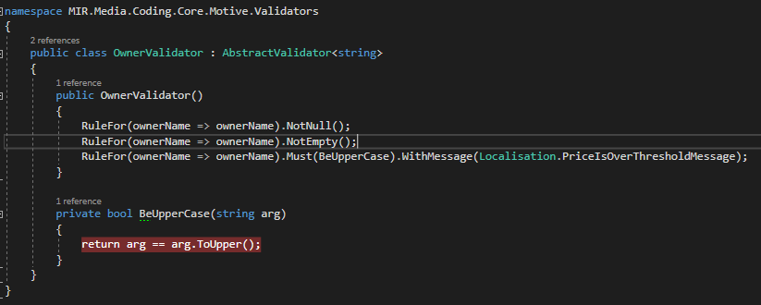

Validace se pak da pouzit v kodu takto:

if (CreateNewOwner)

{

var newName = ByNameOwnerSearchingComboBox.Text.Trim();

var validator = new OwnerNameValidator();

var result =: validator.Validate(newName).IsValid;

if (!IsCzLocation && result == false)

{

Message = Localisation.OnlyUpperCaseLettersAreAllowed;

return;

}

1. Pokud chci zobrazovat error info ve view musim to udelat takto : To horni plati toto je jina verze jako argument si muzu dat objekt comboboxu

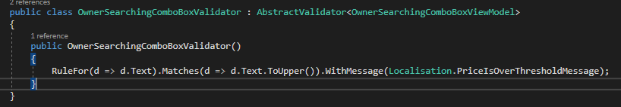

1. V xamlu si v komponente kterou chci validovat dame

<Grid>

<SearchingComboBox1:ComboBox

Text="{Binding Text, UpdateSourceTrigger=PropertyChanged, ValidatesOnDataErrors=True, NotifyOnValidationError=True}" ToolTip="{Binding Path=Error}">

</SearchingComboBox1:ComboBox>

</Grid>

1. A v modelu tohoto comboboxu ( cela trida) nebo v modelu ktery patri k view implementujeme IdataErrorInfo:

namespace MIR.Media.Coding.Core.Motive.SearchingComboBox

{

public class OwnerSearchingComboBoxViewModel : SearchingComboBoxViewModelBase<Owner> , IDataErrorInfo

{

public OwnerSearchingComboBoxViewModel()

{

Text = string.Empty;

Validator = new OwnerSearchingComboBoxValidator();

}

private string m_displayMemberPath;

public string DisplayMemberPath

{

get { return m_displayMemberPath; }

set

{

m_displayMemberPath = value;

NotifyOfPropertyChange(() => DisplayMemberPath);

}

}

private IValidator Validator { get; set; }

public string Error

{

get

{

if (Validator == null)

return string.Empty;

var validation = Validator.Validate(this).Errors.Select(x => x.ErrorMessage).ToArray();

if (!validation.Any())

return string.Empty;

return string.Join(Environment.NewLine, validation);

}

}

public string this[string columnName]

{

get

{

if (Validator == null)

return string.Empty;

var validation = Validator.Validate(this).Errors.FirstOrDefault(e => e.PropertyName == columnName);

return validation == null ? string.Empty : validation.ErrorMessage;

}

}

}

public string Text

{

get { return m_text; }

set

{

m_text = value;

NotifyOfPropertyChange(() => Text);

}

}

}

Tot vse tady se zadne Validator.Validate nevola zvyraznovani stejne funguje.

# [How to validate only 7 digit number?](https://stackoverflow.com/questions/12907242/how-to-validate-only-7-digit-number)

<https://stackoverflow.com/questions/12907242/how-to-validate-only-7-digit-number>

Since you're using FluentValidation, you want to use the .Matches validator to perform a regular expression match.

RuleFor(x => x.student_id).Matches("^\d{7}$")....

.